DEPARTMENT OF ELECTRONICS AND COMMUNICATION ENGINEERING
Course Details
Class : Second Year, B. Tech Semester: II Year: 2024-25
Course Title: LINEAR CONTROL SYSTEMS Course Code: 23A04401 Credits: 3
Program/Dept.: ECE/EVT/ECA Section: A, B, C Batch: 2023-27 Regulation: R-23
Faculty: Mrs.M.Suneetha/Mr.A.Prasad /Mrs.M.Divya Vani
ASSIGNMENT QUESTION BANK
TLO. No: | Unit No: | Question  No | Topic Learning Outcomes/ Question Bank/ MCQ/ Lab Experiments/ Tutorial Task  Labels to the right indicate: CO=Course Outcome, BL=BLOOMS level.  On completion of the Lecture/ Tutorial/ Lab on a topic, students must be able to: | CO | BL | Marks per Q
MODULE -I
CONTROL SYSTEMS CONCEPTS
 | 1 | 1 | (a) Define Control System and Write the Examples of Control Systems. | 1 | 1 | 05
 |  |  | (b) Explain classification of Control Systems. |  | 2 | 05
 | 1 | 2 | Write the merits and demerits of Open Loop and closed loop control systems | 1 | 1 | 10
 | 1 | 3 | Explain effects of feedback on system performance? | 1 | 2 | 10
 | 1 | 4 | Explain Mathematical modeling and transfer function of Electrical and Mechanical systems | 1 | 2 | 10
 | 1 | 5 | Explain the operation of DC Servo Motor and derive the Transfer function | 1 | 2 | 10
 | 1 | 6 | Demonstrate the operation of AC Servo Motor and derive the Transfer function | 1 | 3 | 10
 | 1 | 7 | Analyze the operation of Synchro transmitter and receiver pair. | 1 | 4 | 10
 | 1 | 8 | Obtain the transfer function for the signal flow graph given in figure below, using Mason’s gain formula.  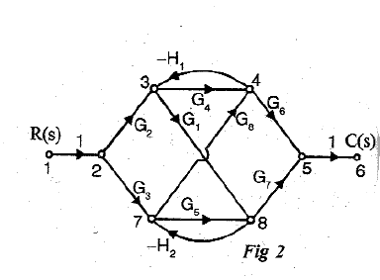 | 1 | 3 | 05
MODULE-II
TIME RESPONSE ANALYSIS
 | 2 | 1 | Explain about various test signals used in the control systems | 2 | 2 | 10
 | 2 | 2 | Describe the Time response of first order system for unit step Input | 2 | 3 | 10
 | 2 | 3 | Analyze the Time response of Un damped & Under damped Second order system for unit step Input. | 2 | 4 | 10
 | 2 | 4 | Analyze the Time response of critically damped and over damped Second order system for unit step Input. | 2 | 4 | 10
 | 2 | 5 | Explain Time domain specifications for transient response? | 2 | 2 | 10
 | 2 | 6 | Calculate the response of unity feedback system whose open loop transfer function (i) (ii) | 2 | 3 | 10
 | 2 | 7 | What is meant by Steady state error. Calculate the Steady state error when the input is (i) Unit Step Signal (ii) Unit Ramp Signal (iii) Unit Parabolic Signal | 2 | 3 | 10
 | 2 | 8 | Transfer function of unity feedback control system is . Obtain the rise time, peak time, maximum overshoot and the settling time when the system is subjected to a unity step input. | 2 | 3 | 10
MODULE-III
STABILITY ANALYSIS IN TIME DOMAIN
 | 3 | 1 | a) Define Stability and classify the different types of stabilities in the control systems. | 3 | 2 | 05
 |  |  | b) Explain the Concept of Location of Poles on the S-Plane for Stability | 3 | 2 | 05
 | 3 | 2 | a) Illustrate the Routh Hurwitz criterion for analyzing the stability | 3 | 3 | 05
 |  |  | b) Write the limitations of Routh’s stability | 3 | 1 | 05
 | 3 | 3 | What are the difficulties in the formulation of the Routh Array table? Explain how they can be overcome. | 3 | 2 | 10
 | 3 | 4 | a) Determine the stability of the system having characteristic equation given below: S³+4s²+6s+4=0 | 3 | 2 | 05
 |  |  | b) Using Routh-Hurwitz criterion, determine the stability of the closed loop system that has the following characteristic equation: 𝑠³ + 5𝑠² + 3𝑠 + 7 = 0. | 3 | 2 | 05
 | 3 | 5 | Determine the Range of K for stability of unity feedback system whose open loop transfer function is G(s) =$\frac{K}{S\left(S+1\right)(S+2)}$ | 3 | 3 | 10
 | 3 | 6 | Explain the rules to construct the root locus for the open loop transfer function. | 3 | 2 | 10
 | 3 | 7 | Explain the effects of adding poles and zeros to G(s)H(s) on the root loci with an example | 3 | 2 | 10
 | 3 | 8 | Sketch the Root locus of a feedback system whose open loop transfer function is given by: G(s) =$\frac{K}{S\left(S+2\right)(S+4)}$ | 3 | 3 | 10
MODULE-IV
FREQUENCY RESPONSE ANALYSIS
 | 4 | 1 | a) Define Transfer function. Write about Frequency domain specifications | 4 | 1 | 05
 |  |  | b) What are the advantages of frequency response analysis | 4 | 1 | 05
 | 4 | 2 | Explain the Procedure for the Construction of Bode plot | 4 | 2 | 10
 | 4 | 3 | Explain the Procedure for the Construction of polar plot with an example | 4 | 2 | 10
 | 4 | 4 | Explain the Procedure for the Construction of Nyquist Plot with an example | 4 | 2 | 10
 | 4 | 5 | Plot the Bode diagram for the following transfer function and obtain the Gain and Phase cross over frequencies. | 4 | 3 | 10
 | 4 | 6 | Sketch the Polar Plots for following cases  (i) Type 0, Order 1 (ii) Type 1, Order 2 (iii) Type 0, Order 2  (iv) Type 0, Order 3 (v)Type 1, Order 3 (vi) Type 2, Order 4 | 4 | 3 | 10
 | 4 | 7 | (a) Draw and Explain Lag Compensator with a neat sketch. Derive the Transfer function. | 4 | 2 | 05
 |  |  | (b) Draw and Explain Lead Compensator with a neat sketch. Derive the Transfer function. | 4 | 2 | 05
 | 4 | 8 | Draw and Explain Lag-Lead Compensator with a neat sketch. Derive the Transfer function. | 4 | 2 | 10
MODULE-V
STATE SPACE ANALYSIS OF CONTINUOUS SYSTEMS
 | 5 | 1 | a)Explain the Concepts of state, state variables and state model | 5 | 2 | 05
 |  |  | b)Write the need for State Space Analysis | 5 | 2 | 05
 | 5 | 2 | Explain the derivation of state models from differential equations | 5 | 2 | 10
 | 5 | 3 | Obtain the state model for the system represented by:  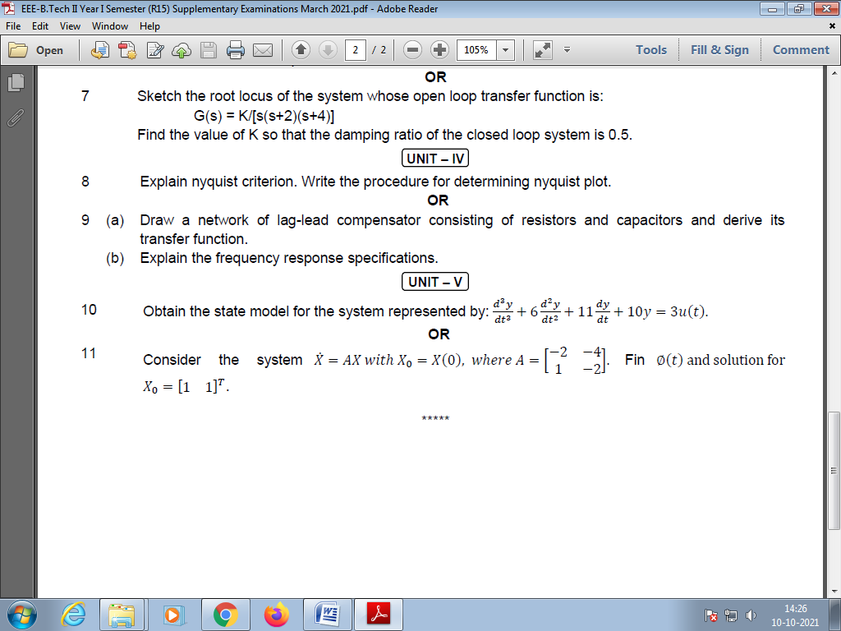 | 5 | 2 | 10
 | 5 | 4 | a) Explain the Process of Diagonalization. | 5 | 2 | 05
 |  |  | b) Diagonalize the system matrix given below:  A=$\left[\begin{matrix}3 & -2 \\ -1 & 2\end{matrix}\right]$ | 5 | 2 | 05
 | 5 | 5 | Let us Calculate the transfer function of the system represented in the state space model as $\left[\begin{matrix}\dot{x1} \\ \dot{x2}\end{matrix}\right]$=$\left[\begin{matrix}-1 & -1 \\ 0 & 1\end{matrix}\right]\left[\begin{matrix}x1 \\ x2\end{matrix}\right]$+$\left[\begin{matrix}1 \\ 0\end{matrix}\right]U$  y=$\left[\begin{matrix}0 & 1\end{matrix}\right]\left[\begin{matrix}x1 \\ x2\end{matrix}\right]$ | 5 | 2 | 10
 | 5 | 6 | Derive the transfer function from the standard state space model. | 5 | 2 | 10
 | 5 | 7 | a)Define and derive the state transition matrix. | 5 | 2 | 05
 |  |  | b)Write the properties of state transition matrix. | 5 | 3 | 05
 | 5 | 8 | Explain the concept of controllability and observability. | 5 | 2 | 10

Faculty HOD

